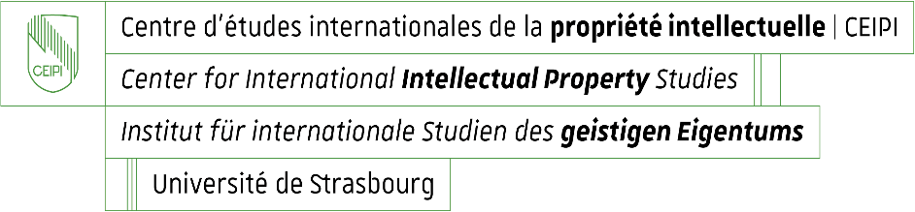

Enrolment for CEIPI courses 2026 – 2027
Questionnaire for information purposes: candidate’s profile and needs / expectations

Name and first name of candidate : _____________________________________________

Please specify your current professional position or situation:

Why do you enrol for the selected training course(s)?
- You intend to take the European Qualifying Examination 2027 and wish to prepare for it.
Yes ☐ No ☐
Paper(s) F M1 M2 M3 M4
☐ ☐ ☐ ☐ ☐

- Other reason ☐
Please specify :

What do you expect from the CEIPI course(s) you are currently enrolling for?

If you have selected the on-site training format : Would you like to inform us about a particular disability or health condition that may require special adjustments? (This information is confidential and used for adaptation purposes only)

