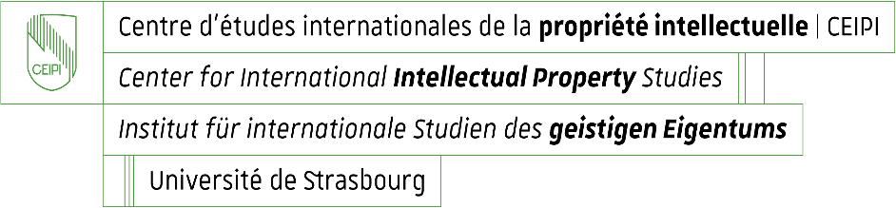

Enrolment for CEIPI courses 2026 – 2027
Questionnaire for information purposes: candidate’s profile and needs / expectations

Name and first name of candidate : _____________________________________________

Please specify your current professional position or situation:

Why are you enrolling for the selected training course?
- You have recently joined a patent firm or patent department of a company and wish to accompany the practice of your profession by systematic and complete tuition on the legal basis as well as on practice in the area of European patent law

Yes ☐ No ☐

- You intend to take Paper F of the European Qualifying Examination in 2026
Yes ☐ No ☐

- Other reason ☐
Please specify :

What do you expect from the CEIPI course you are currently enrolling for?

If you h ave selected the on-site training format: Would you like to inform us if about a particular disability or health condition that may require special adjustments? (This information is confidential and used for adaptation purposes only)

___________________________________________________________________________

