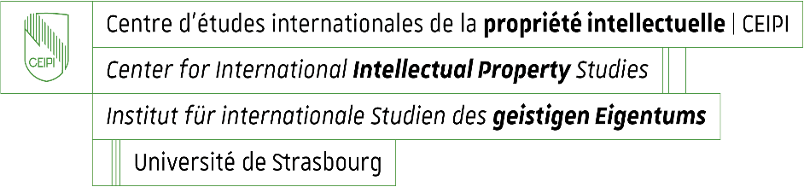

**Enrolment for CEIPI courses 2025 – 2026**

**Questionnaire for information purposes: candidate’s profile and needs / expectations**

Name and first name of candidate : _____________________________________________

Please specify your current professional position or situation:

Why do you enrol for the selected training course(s)?

1. You intend to take the European Qualifying Examination 2026 and wish to prepare for it.

Yes  No

**Paper(s) F A B C D M1 M2**

1. Other reason

Please specify :

What do you expect from the CEIPI course(s) you are currently enrolling for?

If you have selected the on-site training format : Would you like to inform us about a particular disability or health condition that may require special adjustments? (This information is confidential and used for adaptation purposes only)