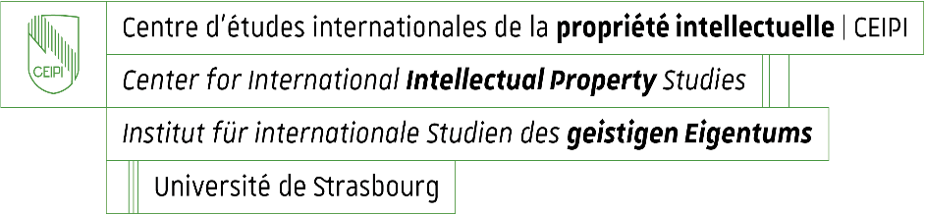

**Enrolment for CEIPI courses 2025 – 2026**

**Questionnaire for information purposes: candidate’s profile and needs / expectations**

Name and first name of candidate : _____________________________________________

Please specify your current professional position or situation:

Why are you enrolling for the selected training course ?

1. You intend to take the EPAC examination 2025 and wish to prepare for it

Yes  No

1. Other reason

Please specify :

What do you expect from the CEIPI course you are currently enrolling for ?