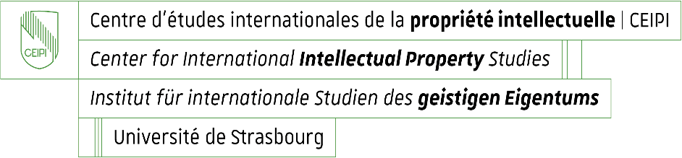

Enrolment for CEIPI courses 2025 – 2026
Questionnaire for information purposes: candidate’s profile and needs / expectations

Name and first name of candidate : _____________________________________________

Please specify your current professional position or situation:

Why are you enrolling for the selected training course ?
- You intend to take the EPAC examination 2026 and wish to prepare for it
Yes ☐ No ☐
- Other reason ☐
Please specify :

What do you expect from the CEIPI course you are currently enrolling for ?

